The Case Against Raising The Federal Funds Rate

Just in case you haven’t noticed, inflation is pretty bad. To try to help combat high inflation the federal reserve has been raising the federal funds rate (FFR[1]) pretty steadily since March. For a while now debate has been swirling, first over if the U.S. was experiencing too high a level of inflation and then over how aggressive the federal reserve should be in raising interest rates. One question that has not been asked is if raising the FFR is actually a good measure for lowering inflation given our current economic conditions. Now I know it seems somewhat crazy to think that raising the FFR would not have deflationary effects but it is an important question to answer. I see two possible ways for raising the FFR to be ineffective. First given current economic conditions the deflationary effects normally associated with raising the FFR are less severe than expected. Second, raising the FFR causes unintentional inflationary effects that outweigh the deflationary effects of raising the FFR. The goal of this argument is not to prove that raising the FFR is currently not working but instead to explore a question that is currently under-analyzed in my opinion.

Labor Market Look

One main theory behind inflation is what I will call the wage-unemployment theory[2]. More specifically in classical economics that inflation is equal to expected inflation plus the difference between actual unemployment minus “natural unemployment” times some constant[3]. No need to write that down, I am not going to go in-depth on the actual equation but I instead want to talk a bit about the theory of it. More specifically the idea that lower unemployment leads to higher inflation. The argument goes that if unemployment is low then it should be harder for companies to find labor and they will raise wages to bring in laborers, this rise in wages will then feed into prices. It is a fun theory and one that has some good ideas baked into it. Most notably, if there is a shortage of labor in the economy those demanding labor will pay more for labor and then pass the price increase on to those buying goods. This argument does have some clear weaknesses though. First if you have higher rates of unemployment because people do not want to work then high unemployment could exist with high inflation.[4] At the same time one could have low unemployment but little inflation if demand and supply are well matched. Really the point here is that labor based inflation is not caused by an arbitrary unemployment number, but instead by a gap between the supply and demand of labor.[5] Labor based inflation is something that occurs when markets are “adjusting” themselves to find a new sort of equilibrium. Since around 2019 U3 unemployment[6] has remained below 4% (minus 2020 Covid reaction). Some used this as reasoning to argue that the federal reserve should raise interest rates to stem future inflation. Others took the side that instead there had been a shift in what the “natural rate of unemployment” was and that no action needed to be taken by the fed. In 2022 inflation began to pick up and in response the federal reserve did begin to raise interest rates.

So why would the FFR be an adequate strategy for fighting unemployment rates? One argument would be that it lowers labor from a demand side. More specifically, that increasing the FFR leads to a decrease in investment spending which indirectly affects the demand for labor. This decrease in demand of labor should then lead to higher unemployment and thus lower inflation. Or from a supply-demand side lower demand should lead to lower prices(wages) thus a slow down in inflation. But what if demand and supply are currently not matching? When we look at Job Openings versus hirings one can easily see that there is an inordinately large gap between the supply and demand of labor that began in roughly 2018 and was exacerbated by the pandemic.

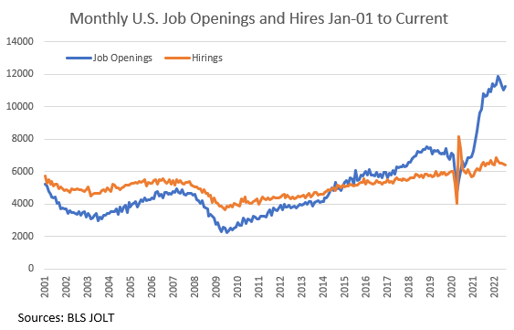

Again the fed can really only affect the demand side through the FFR.[7] Now I do not know the specific level/ratio/gap between the two that is needed for it to start affecting the unemployment rate, and more importantly for us, wages, but when we look at the graph above demand(job openings) looks to have a long way to fall before it will start to cause a decrease in either employment or wages.

The argument can then be made that increasing the FFR will have little effect on inflation in the near term as the large effects it needs to have on the demand for labor are unlikely to happen in the short term. For this reason raising the FFR will likely be ineffective at reducing labor based inflation.

Housing Market

One of the biggest and clearest places the federal reserve's policies has had an effect is in the housing market. I could do a relatively mediocre job explaining why the FFR affects housing demand but I am going to assume you: already understand the theoretical argument, can find a better explanation online, or don’t care about the theory. What does the data say?

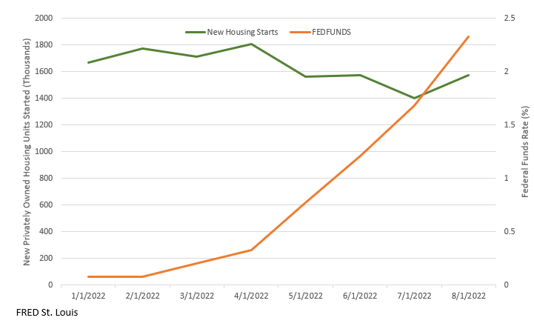

Well it's not the most data, but look at the first 8 months of the year there does seem to be some evidence that the increases in FFR are cooling down the supply of new housing. It might not be the most convincing argument but let's just assume that it is having a deflationary effect on the supply of new housing. Do we really want to decrease the supply of new housing? Considering we are in a bit of a “housing crisis” I am not particularly sure if decreasing new housing starts is really the best way to stem inflation. Yes building new houses costs a lot of money and new housing owners tend to spend a lot of money on their new houses so having fewer houses being built will cool down the overall economy but again the goal is to reduce inflation. And when we look at inflation, housing makes up a large percentage of consumer spending, more than any other sector to be exact. Considering the fact that we already have housing inflation, is decreasing the supply really a smart move?

Now as all the angsty critics have probably already noticed this is only looking at the housing market from the supply side. Fed policy will also affect the demand for housing and looking at new privately-owned housing sales one can see this affect pretty clearly.

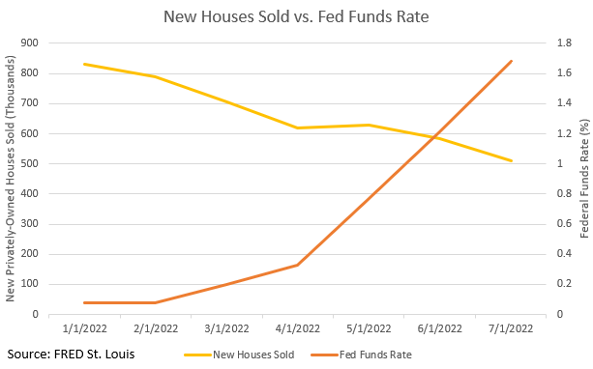

The problem is new privately-owned houses do not represent the full housing supply or demand. We could bring in used housing sales as well but still this would be leaving out renters. Rental vacancy rates are currently sitting at their lowest rates in over 30 years[8]. When we take this into account it is not that overall demand for housing is decreasing, instead that consumers are shifting to relatively cheaper options. In actuality, demand is not decreasing. This is likely being reflected in the current CPI shelter index which has seen relatively consistent growth despite the fed policy measures.

This brings us to the big elephant in the room. It seems that increases in the FFR are directly decreasing housing supply while having no substantial effect on the overall demand for housing. From basic supply and demand if demand is constant and supply decreases then prices should increase. It can then be argued that by increasing FFR the fed are decreasing housing supply and driving up inflation the opposite of their aim.

Synopsis

First I want to reiterate that the point of this post is not to prove that raising the FFR is currently ineffective but instead to investigate a question that is currently not being explored. On top of that this post does not really go in depth on the issue. All I have is a master’s in economics and just barely. There are many other ways in which the FFR affects both the U.S. economy and inflation that are not explored in this post. On top of that one could go much deeper into the two areas talked about and could also be much more pragmatic in exploring these questions. In all reality I have neither the knowledge or expertise to do either of these things so I didn’t. As historian Dan Carlin once said, “I may not be qualified to give answers but I can ask questions.” And that is what the aim of this post is, to ask a question.

1. At points I will use interest rates interchangeably with FFR to add variety.
2. There is most likely a more technical term for this that I have either not been educated in or more likely have forgotten.
3. [Wiki on Phillips Curve](https://en.wikipedia.org/wiki/Phillips_curve)
4. The idea here more or less that people are more picky about the jobs they take on and have a willingness to stay unemployed for longer periods of time.
5. One could debatable argue that labor based inflation is just a period in which the labor market is transitioning to a new equilibrium.(In theory there is no perfect equilibrium and labor markets are always changing leading to some wage based price changes, it is only when extreme changes in the labor market occur that we start to talk about wage based inflation)
6. U3 Unemployment only categorizes those that are “actively looking for a job” as being unemployed while U6 includes a more broader base including those that are underemployed and marginally attached. More can be found about how the BLS calculates unemployment at: <https://www.bls.gov/cps/cps_htgm.htm>
7. As openings are higher than hirings I think hirings can be used as a fairly good measure for the supply of labor.There does not seem to be any strong evidence that hirings has increased since the fed began raising the f.f.r. Quickly comparing y/y numbers 2022 have been higher than 2021 since March, but they were also higher before March so I do not think there is any strong evidence that the fed’s policy has had any effect. More notably, it is not meant to affect the supply of labor. In theory allowing for higher inflation would probably lead to higher supply as people would be more incentivized to work.
8. 1984 was the last time rental vacancy rates were as low. Direct Source: <https://fred.stlouisfed.org/series/RRVRUSQ156N>

   A more indepth look at recent rent situation:

   <https://www.census.gov/housing/hvs/files/currenthvspress.pdf>